**Testing a model to track marine fish migrations in polar regions using archival satellite tags**

*Bjørn Ådlandsvik1, Cedar M. Chittenden2, Ole-Petter Pedersen2, David Righton3 and Audun H. Rikardsen2

# *1Institute of Marine Research, P.O. Box 1870, Nordnes, N-5817 Bergen, Norway*

*2Department of Arctic and Marine Biology, University of Tromsø, N-9037 Tromsø, Norway*

*3Center for Environment, Fisheries and Aquaculture Science, Pakefield Road, NR33 0HT Lowestoft, UK*

\**Correspondence*. e-mail: bjorn.adlandsvik@imr.no

**Abstract**

The use of pop-up archival satellite tags (PSATs) to geolocate marine fishes in polar regions is challenging due to the brevity of periods during which there is a defined sunrise and sunset. Models using other environmental parameters, such as temperature and depth, are thus required to supplement geolocation data in the estimation of marine migratory routes. A forward/backward-Lagrangian model using biased random walks was adapted to satellite tag data from migrating Atlantic salmon (*Salmo salar*), and estimated geolocations were used to test and constrict the model. The model accurately predicted migratory routes that fit the light-based geolocations calculated by the tags. Sensitivity analyses demonstrated that slight alterations of the start and end points did not significantly affect the mean migratory route estimates. This model can be applied to archival tag data from any surface- or bottom-dwelling marine species and supplemented, if desired, with light-based geolocation methods.

**Key words**: Arctic, SST, telemetry, archival tag

**Introduction**

Satellite telemetry has been used for decades to track marine migratory species, including reptiles (e.g. Luschi *et al*., 1996; Hughes *et al*., 1998), birds (e.g. Jouventin and Weimerskirch, 1990; Georges *et al*., 1997), and mammals (e.g. Lowry *et al.*, 1998; Richards *et al*., 1998). As satellite tags do not require an animal to be recaptured in order for data to be obtained, they are particularly useful for species with long migrations in the open ocean (Mate *et al*., 1998; Gillespie, 2001). However, for data to be uploaded to a satellite, the tag’s antenna must be pointing upward and in air—making the study of most fish species all but impossible. Pop-up satellite archival tags, or PSATs, are a recently developed technology for the study of aquatic species (Aarestrup *et al*., 2009; Block *et al.* 2010). PSATs are buoyant and can be programmed to release from a tagged animal on a certain date, or when an animal has remained at a constant depth for a pre-determined period of time (in the case of a probable mortality). Once at the surface, the tag transmits the stored environmental data to passing satellites. PSATs have been tested on several large marine fish species (e.g. Lutcavage *et al.*, 1999; Arrizabalaga *et al.*, 2008) and have recently been made compact enough to be used on smaller fish (Aarestrup *et al.*, 2009).

PSAT tags generally record the temperature, depth and light intensity at regular time intervals, although other types of environmental sensors can be attached (e.g. salinity, chlorophyll recorders; Teo *et al.,* 2009). Algorithms programmed into the tags calculate geolocations (latitude and longitude) using estimates of sunrise and sunset derived from collected light-level data. For locations at which sunset and sunrise are defined by rapid and large changes in visible light-level, light-based geolocation is effective. However, at polar latitudes (north of the Arctic Circle, south of the Antarctic Circle), where light levels are often low, and the difference in light-level between night and dawn/ dusk is minimal, accurate geolocation estimates are possible only during brief periods before and after the spring and autumn equinoxes (Fig. 1). Even during these periods of possible geolocation, the difference in irradiance between day and night is much less than in tropical regions, which adds error to the estimates. Furthermore, the duration of twilight is greater at higher than at lower latitudes, making the estimation of exact sunrise and sunset time challenging, especially with the additional confounding factors acting to lower light levels (e.g. diving behaviours or adverse weather conditions). In consequence, most PSAT-based studies of migratory behaviour of marine animals have been focused on species that spend time at lower latitudes, such as bluefin tuna (Block *et al*., 2005) or leatherback turtles (Hays *et al*., 2006).

Information on the migration and distribution of fishes at high latitudes is highly important, as these areas support some of the most lucrative fisheries in the world. However, many of these stocks are becoming severely depleted (Sakshaug *et al.* 2009). For example, anadromous Atlantic salmon (*Salmo salar*) and Pacific salmon species (*Oncorhynchus* spp.) undertake long foraging migrations into northern oceans where observational studies are challenging (Hansen *et al*., 1993;Hansen and Quinn, 1998; Rikardsen *et al*., 2008; Thorstad *et al.*, 2011). The open-ocean migratory behaviour of salmonids has been pieced together over the last century from fishing catch data and mark-recapture studies (Hansen *et al.,* 1993;Hansen and Jacobsen, 2000; Rikardsen *et al.*, 2008). In short, there exists almost no data beyond commonly fished areas and data density is low and, without any continuous real-time data, great knowledge gaps exist in terms of the actual marine distribution of salmon, salmonid migratory routes, and environmental effects on salmonid marine behaviour (Chittenden *et al.*, 2009). Satellite tags are perhaps the only technology currently available that could enable researchers to overcome this problem and fill the existing gaps. Although, with the problems associated with light-based geolocation at polar latitudes, additional methods to determine location are required.

A number of different approaches have been applied to the problem of predicting the state-space of migrating organisms. In general, they differ with respect to the applied theoretical frameworks, forcing fields, and data assimilation methods (i.e. to which extent the model is able to incorporate and use external data as correctors). In the simplest cases, models have been developed that can reconstruct the horizontal movements of migrating fish by matching hydrographical fields to data collected by tagged fish (Metcalfe and Arnold, 1997; Righton and Mills, 2006; Ådlansvik *et al*., 2007; Tremblay *et al.*, 2009). More complex models use various statistical techniques, including Bayesian models (Kurota *et al*., 2009), bootstrapping techniques (Tremblay *et al.*, 2009), and weighted kernel estimation techniques (Walli *et al*., 2009) to provide likelihood-based estimates of geolocation. The variety of modeled and measured physical fields that have been applied to force and correct the migratory trajectories that result grows year on year (Booker *et al*., 2008).

Our model approach was to use a forward/backward-Lagrangian model with a biased random walk (Patterson *et al.*, 2007; Ådlandsvik *et al.*, 2007) to plot the migratory pathways of two PSAT-tagged salmon in the Arctic. We used the model described in Ådlandsvik *et al.* (2007) as a starting point. This model was created to re-construct the migratory pathways of Northeast Arctic cod (*Gadus morhua* L.) Whereas cod are bottom-dwellers, salmonids are surface-oriented, using the top 10 m of the water column for primary habitat during their saltwater phase (Rikardsen and Dempson, 2011). Thus, the model required some fine-tuning to reflect the behaviour of a surface-dwelling species.

The objectives of our work were fourfold:

1. To adapt the method of Ådlandsvik *et al*. (2007) to salmon behaviour data;
2. To test the accuracy of the model with validated PSAT geolocation data;
3. To run a sensitivity analysis on the model, altering the release and pop-up locations; and
4. To use the geolocations as stop/start points to constrain the model and improve the accuracy of the predicted trajectories.

**materials and Methods**

*The salmon data*

Two PSAT datasets from female salmon kelts were used to test the model. A ‘kelt’ is a post-spawned adult salmon that leaves its freshwater spawning grounds to return to ocean feeding areas (Thorstad *et al.*, 2011). The fish were caught by anglers during late May in the Alta River (70°N 23°E), northern Norway (Fig. 2). A PSAT tag, recording temperature, depth and geolocation (Model: X-tags; 12 cm length + 20 cm antenna, diameter 16 - 32 mm, mass 42 g in air, Microwave Telemetry, Colombia, USA), was attached externally to each fish by bridling the tag to two cushioned backplates that were wired through the dorsal musculature below the dorsal fin. A small acoustic tag (9 mm diameter, Thelma Biotel, Norway) was also attached to one of the backplates so that the fish could be tracked as they moved out of the fjord after release. Following surgery, the tagged salmon were transported to the release site beyond the main fishing areas (Fig. 2) by boat. The fish in this study were in excess of 1m in length (Tag 1: 111 cm long, 9.9 kg; Tag 2: 101 cm long, 7.6 kg). They were released on the 22 May 2008 and took approximately three days to leave the release fjord.

The tags released from their attachments after 181 days (Tag 1; after a minimum distance of 472 km from the release site) and 146 days (Tag 2; minimum 579 km). The tags had popped up earlier than their programmed pop-up date, presumably because the ‘constant depth’ failsafe was triggered after each tag had spent four consecutive days at the sea surface. It is probable that the tags and harnesses had detached from the fish (by predation). The tags were likely drifting with surface currents for four days prior to the initialisation of uploading their location to the ARGOS satellites. Therefore, a back-calculation of the initial pop-up location was required. The real-time ARGOS geolocation on the fourth day after the tag initiated contact with the satellites was used to determine the four-day change in latitude and longitude experienced by the tags due to surface currents. These latitudinal and longitudinal differences were then subtracted from the initial pop-up location to give the actual pop-up site.

The tag data were prepared for the model by computing maximum depth and daily averages of SST. Missing data were filled in by linear interpolation. Rapid changes in temperature recorded by the tag were smoothed by a 7-day? moving average, to fit the lower resolution of the SST archive. Sub-grid variation was also accounted for by thresholds for termination. These thresholds were narrow, so that the termination criteria were effective and provided a good selection pressure for the trajectories. However, they were flexible enough to give a reasonable subset of active trajectories. List the thresholds (in a table? Or just text)

Unlike PSAT data obtained at lower latitudes, the longitude estimates from tags deployed in polar regions are unreliable during most of the year. This precludes the use of established validation methods, where longitude is ‘fixed’ and matched with SST data at a range of latitudes (e.g. Teo *et al.*, 2004). Another method was developed here to validate the geolocations from polar latitudes.

A first filtering deleted those outliers that were on land and those arising from false sunset/sunrise calculations (e.g. due to deep diving behaviour). A second filtering removed those data points that had temperatures 0.5°C above or below the actual sea-surface temperature (SST) at that location. Two temperature parameters were calculated from the tag data: 1) the mean daily temperature recorded at <10 m and 2) the mean daily temperature at <5 m. SST data within 0.5° latitude and longitude of each geolocation provided by the tags were extracted from the daily SST product provided by OSTIA (http://ghrsstpp.metoffice.com/pages/latest_analysis/ostia.html). If the temperature parameters were within 0.5°C of the SST ±0.5° latitude/longitude, the geolocation was deemed valid.

*Adapting the model*

The model in Ådlandsvik *et al.* (2007) creates a set of trajectories consistent with the available information from each tag. Two sets of trajectories are generated—one progressing forward from the release site, and one progressing backward from the pop-up position. The trajectories progress by combining a deterministic and a stochastic velocity component. The deterministic component pulls the particle at a velocity that would get the particle to the final position during the time available. The stochastic component is a random walk velocity, with a fixed speed and an arbitrary/random direction. After each time step (one day), the environmental (depth and temperature) dataset was sampled at the position of the trajectory. If the tag data were not consistent with the environmental data at the new position, the trajectory was given a second chance by returning it to the previous position. If the previous position also failed, the trajectory was terminated. As a final step, the forward and backward trajectories were merged at the temporal midpoint between the release and pop-up sites. This was done by looping through the active forward trajectories and choosing the nearest backwards trajectory if the midpoint positions were closer than a given threshold (for further details and a step-by-step guide to the trajectory algorithm, see Ådlandsvik *et al.,* 2007).

To adapt the model used in Ådlandsvik *et al.* (2007) to the surface-oriented salmon data, sea-surface temperature (SST) was used instead of temperature estimates from the entire water column. As SST has greater accuracy than temperatures estimated at depth, this perhaps increased the accuracy of the model. The SST data were acquired from the gridded dataset NOAA_OI_SST_V2, which is provided online by the NOAA Earth System Laboratory on their website <http://www.esrl.noaa.gov/psd/> (Reynolds *et al.,* 2002). This dataset has one-degree-spatial and one-week-temporal resolution. The model samples the datasets at the track positions by multi-linear interpolation. For temperature, a symmetric two-sided criterion was used. Each trajectory had to satisfy the criterion:

| TSST - Ttag | < dT (Equation 1)

For depth, the gridded ETOPO1 bathymetry dataset was obtained from the NOAA National Geophysical Data Center (<http://www.ngdc.noaa.gov/mggd/>; Amante and Eakins, 2009). This data set has a resolution of one minute.Depth was used as a one-sided limiter terminating trajectories where the sampled depth (Hetopo) was shallower than the tag’s recorded depth. The limiter had the following algebraic formulation:

Htag < a*Hetopo + H0  (Equation 2)

Bjørn: Include more details about how the model was adapted to the salmon tag data (you had suggested a table?) Also, can you add the methods for the sensitivity analysis, calculation of error, and how you constrained the tracks through the geolocations?

**Results**

*Modelling salmon tracks*

For Tag 1, a total of 21,556 merged tracks resulted from 100,000? particles (Fig. 3a). The mean track headed northwards for the first 60 days, then turned southwards for 40 days before heading northwards again, and veering northeast along the 400 m isobaths (Fig. 3a). When the tag data (Fig. 3b) were compared with the modelled tracks, we found that the salmon kelts undertook some deep dives at the end of July (>300 m), which meant that the trajectory had to go straight north to reach the deeper areas by that time. Towards the end of August and during the first half of September, the temperature recordings increased (>9°C), which meant that the salmon must have been further south to fit the SST data. From the end of September onward, the kelts began diving more deeply again (>400 m), which forced the un-terminated tracks northward to the Bear Island Trench. The colder temperature recordings and the short period before the pop-up date then forced the tracks towards the northeast.

How many particles were tried for Tag 2? How many merged tracks?

The data from Tag 2 also showed deep dives during late July (~300 m). However, as the dives were slightly shallower than those for Tag 1, the trajectories were not forced so far northward as they were for Tag 1 (Fig. 4). Without any further depth constraints, and only moderate temperature recordings, the track for Tag 2 veered further east and progressed at a steady pace towards the pop-up location (Fig. 4).

*Testing the model with geolocations*

Accurate geolocations were possible to obtain from irradiance during two periods of the study; late August/early September and October. Near the autumnal equinox (22 September) daylength is the same at all latitudes, and during summer/winter there are 24 hours of daylight/darkness, both of which make geolocating using sunlight impossible. Tag 1 had a greater number of rejected geolocation estimates, and fewer validated geolocation estimates than Tag 2 (Fig. 5). Six out of the eight geolocations fit the center of gravity of the particle locations (Fig. 6a). One of the geolocations (2008-09-12) was not eliminated during the SST filtering, but when the likely swimming speed of the salmon was considered, it was deemed implausible and removed from further analyses.

For Tag 2, the 24 geolocations tended to be further east than the center of gravity of the modelled particles (Fig. 6b). The cause of this discrepancy is likely the fact that the pop-up location was between the geolocations and the release site. This meant that the deterministic veolocity component would not have been great enough initially for a majority of the trajectories to reach the geolocation sites.

*Model sensitivity analysis*

A sensitivity analysis on the data from Tag 1 found that moving the release and pop-up locations <100 km did not change the overall pattern formed by the data from the tag and the environment (Fig. 7). The mean was robust and did not depend critically on either the release or pop-up locations (Bjørn can you add some sort of error range?)

*Constraining the model through geolocations*

When the model was constrained to pass through the validated geolocations, the proportion of trajectories was reduced and the path took a slightly different route than the unconstrained mean. Bjørn, see comments on Figure 8 (sausage plot). An additional plot for Tag 2 would be great (8b), to compare the two tags and test whether constraining the model really changes the look of the Tag 2 trajectories (which I think it will since the geolocations are further east than the pop-up location, see above).

**Discussion**

During times when it is not possible to monitor migrating animals using light-based geolocation, other methods are required. Our forward/backward-Lagrangian model using biased random walks was successful at reconstructing the migratory routes of Atlantic salmon using only temperature and depth recordings from a PSAT tag. Sensitivity analyses found that slight alterations of the start and end points did not change the mean trajectory route, suggesting that the model was robust and that the reconstructed tracks reflect the genuine migration of the salmon kelts, rather than model artefacts. Constricting the trajectories through validated geolocations may add further accuracy to migration route reconstructions.

The adaptation of a model created to track cod behaviour (Ådlandsvik *et al*., 2007), to fit salmon behaviour data from PSAT tags, was successful in predicting the validated geolocation data within 100 km. However, if the fish doubled-back towards the release site, so that the pop-up location was closer to the release site than some of the geolocations, the model tended to pull the trajectory towards a more direct route (e.g. Tag 2). When the trajectories were constrained to pass through the geolocations, this bias was reduced.

It has been hypothesized that migratory fishes use the offshore currents to reach marine feeding grounds (Dadswell *et al.,* 2010). The trajectories predicted by the model were consistent with this hypothesis and previous mark-recapture studies of salmon migratory behaviour (Hansen *et al.*, 1993; Rikardsen *et al.*, 2008; Rikardsen and Dempson, 2011; Thorstad *et al*., 2011). Our modeled trajectories and geolocations suggest that Atlantic salmon released from rivers in northern Norway travelled north towards Svalbard and eastward into the Barents Sea, which fits the results of earlier studies (Rikardsen *et al.,* 2008; Thorstad *et al*., 2011).

Along the migratory timeline, the trajectories were initially terminated due to reasons of depth—i.e. the depth recording from the tag was greater than the depth at the modelled particle’s location. The tags’ depth data showed that the salmon left the coastline area fairly quickly (less than one month after release). Later on, temperature became the more limiting factor as the particles had all entered the ~300 m-deep Barents Sea. The Barents Sea has a large SST gradient as a result of warmer Atlantic waters from the southwest mixing with cooler Arctic waters from the northeast (the polar front). This high degree of temperature variation allowed for more precision in modelling the migratory routes of salmon when depth was fairly uniform.

Even during the prime times for geolocating based on irradiance times (late August/early September and October), the tags calculate widely variable geolocations, perhaps due to deep dives, changes in weather, or a lack of sensitivity in the tag algorithm at detecting exact sunrise/sunset times. Thus, even the validated geolocations likely contain some error. A greater number of geolocations were validated for Tag 2, which may have been a result of clearer weather in the eastern Barents Sea where the tag was located, allowing for a more precise measurement of sunrise/sunset time. Further evaluation of the accuracy of geolocations calculated by PSATs at high latitudes is required.

**conclusion**

This forward/backward-Lagrangian model is a straightforward and intuitive way to predict the migratory routes of marine species using only temperature and depth recordings from archival tags, and can easily be adapted to use other parameters such as salinity, chlorophyll, or magnetic-field recordings. For added accuracy, the model can be constrained through geolocation points from PSAT tags. It has great potential for the tracking of polar species, where geolocation estimates are not possible during most of the year.

**Acknowledgements**

We thank Kathrine Michalsen, Jenny Jensen, Ceselie Lien, Amund Suhr, the Norwegian Research Council, and the Alta Laksfiskeri Interessentskap for their assistance.

**References**

Aarestrup, K., Økland, F., Hansen, M.M., Righton, D., Gargan, P., Castonguay, M., Bernatchez, L., Howey, P., Sparholt, H., Pedersen, M.I. and McKinley, R.S. (2009) Oceanic Spawning Migration of the European Eel (*Anguilla anguilla*). *Science* **325**:1660.

Amante, C. and Eakins, B.W. (2009) ETOPO1 1 Arc-Minute Global Relief Model: Procedures, Data Sources and Analysis. NOAA Technical Memorandum NESDIS NGDC-24, 19 pp, March 2009.

Arrizabalaga, H., Pereira, J.G., Royer, F., Galuardi, B., Goni, N., Artetxe, I., Arregi, I. and Lutcavage, M. (2008) Bigeye tuna (*Thunnus obesus*) vertical movements in the Azores Islands determined with pop-up satellite archival tags. *Fish. Oceanog.* **17**:74–83.

Batchelder, H.P. (2006) Forward-in-time-/backward-in-time trajectory (FITT/BITT) modeling of particles and organisms in the coastal ocean. *Am. Meteor. Soc.* **23**:727–741.

Block, B.A., Teo, S.L.H., Walli, A., Boustany, A., Stokesbury, M.J.W., Farwell, C.J., Weng, K.C., Dewar, H. and Williams, T.D. (2005) Electronic tagging and population structure of Atlantic bluefin tuna. *Nature* **434**:1121–1127.

Booker, D.J., Wells, N.C. and Smith, P.I. (2008) Modelling the trajectories of migrating Atlantic salmon (*Salmo salar*). *Can. J. Fish. Aquat. Sci.* **65**:352–361.

Chittenden, C., Beamish, R.J and McKinley, R.S. (2009) A critical review of Pacific salmon marine research relating to climate. *ICES J. Mar. Res.* **66**:2195–2204.

Dadswell, M.J., Spares, A.D., Reader, J.M. and Stokesbury, M.J.W. (2010) The North Atlantic subpolar gyre and the marine migration of Atlantic salmon *Salmo salar*: the ‘Merry-Go-Round’ hypothesis. *J. Fish Biol*. **77**:1095–8649.

Georges, J., Guinet, C., Jouventin, P. and Weimerskirch, H. (1997) Satellite tracking of seabirds: interpretation of activity pattern from the frequency of satellite locations. *IBIS.* **139**:403–405.

Gifford, A., Compagno, L.J.V., Levine, M. and Antoniou, A. (2007) Satellite tracking of whale sharks using tethered tags. *Fish. Res.* **84**:17–24.

Gillespie, T.W. (2001) Remote sensing of animals. *Progr. Phys. Geog.* **25**:355–362.

Hansen, L.P. and Quinn, T.P. (1998) The marine phase of the Atlantic salmon (*Salmo salar*) life cycle, with comparisons to Pacific salmon. **55**:104–118.

Hansen, L.P. and Jacobsen, J.A. (2000) Distribution and migration of Atlantic salmon *Salmo salar* L., in the sea. In: *The Ocean Life of Atlantic Salmon – Environmental and Biological Factors Influencing Survival.* D. Mills (ed). Oxford: Fishing News Books, pp. 75–87.

Hansen, L.P., Jonsson, N. and Jonsson, B. (1993) Oceanic migration in homing Atlantic salmon. *Anim. Behav.***45**:927–941.

Hays, G.C., Hobson, V.J., Metcalfe, J.D., Righton, D. and Sims, D.W. (2006) Flexible foraging movements of leatherback turtles across the North Atlantic Ocean. *Ecology* **87**:2647–2656.

Hughes, G.R., Luschi, P., Mencacci, R. and Papi, F. (1998) The 7000-km oceanic journey of a leatherback turtle tracked by satellite. *J. Exp. Mar. Biol. Ecol.* **229:**209–17.

Jerlov, N.G. and Nielsen, E.S., Eds. (1974) *Optical aspects of oceanography*. Academic Press, London, New York. 494 pp.

Jouventin P. and Weimerskirch, H. (1990) Satellite tracking of wandering albatrosses. *Nature* **343**:746–748.

Kurota, H., McAllister, M.K., Lawson, G.L., Nogueira, J.I., Teo, S.L.H. and Block, B. (2009) A sequential Bayesian methodology to estimate movement and exploitation rates using electronic and conventional tag data: application to Atlantic bluefin tuna (*Thunnus thynnus*). *Can. J. Fish. Aquat. Sci.* **66**:321–342.

Lowry, L.L., Frost, K.J., Davis, R., DeMaster, D.P. and Suydam, R.S. (1998) Movements and behavior of satellite-tagged spotted seals (*Phoca largha*) in the Bering and Chukchi Seas. *Polar Biol.* **19**:221–230.

Luschi, P., Papi, F., Liew, H.C. and Chan, E.H. (1996) Long-distance migration and homing after displacement in the green turtle (*Chelonia mydas*): a satellite tracking study. *J. Comp. Physiol.* **178**:447–52.

Lutcavage, M.E., Brill, R.W., Skomal, G.B., Chase, B.C. and Howey, P.W. (1999) Results of pop-up satellite tagging of spawning size class fish in the Gulf of Maine: do North Atlantic bluefin tuna spawn in the mid-Atlantic? *Can. J. Fish. Aquat. Sci.* **56**:173–177.

Mate, B.R., Gisiner, R. and Mobley, J. (1998) Local and migratory movements of Hawaiian humpback whales tracked by satellite telemetry. *Can. J. Zool.* **76:**863–68.

Metcalfe, J.D. and Arnold, G.P. (1997) Tracking fish with electronic tags. *Nature* **387**:665–666.

Patterson, T.A., Thomas, L., Wilcox, C., Ovaskainen, O. and Matthiopoulos, J. (2007) State-space models of individual animal movement. *Trends Ecol. Evol.* **23**:87–94.

Pedersen, O.P., Tande, K.S. and Slagstad, D. (2000) A synoptic sampling method applied to *Calanus finmarchicus* population on the Norwegian mid-shelf in 1997. *Mar. Ecol. Prog. Ser.* **204**:143–157.

Pedersen O.P., Aschan, M., Rasmussen, T., Tande, K.S. and Slagstad, D. (2003) Larval dispersal and mother populations of *Pandalus borealis* investigated by a Langrangian particle-tracking model. *Fish. Res.* **65**:173–190.

Reynolds, R.W., Rayner, N.A., Smith, T.M., Stokes, D.C. and Wang, W. (2002) An improved in situ and satellite SST analysis for climate. *J. Climate* **15**:1609–1625.

Richards, P.R., Heide-Jorgensen, M.P. and Aubin, D.S. (1998) Fall movements of Belugas (*Delphinapterus leucas*) with satellite-linked transmitters in Lancaster Sound, and northern Baffin Bay. *Arctic* **51**:5–16.

DR: Righton D. and Mills…(2006)

Rikardsen, A.H., Hansen, L.P., Jensen, A.J., Vollen, T. and Finstad, B. (2008) Do Norwegian Atlantic salmon feed in the northern Barents Sea? Tag recoveries from 70 to 78°N. *J. Fish Biol.* **72**:1792–1798.

Rikardsen, A.H. and Dempson B. (2011) Dietary life-support: The marine feeding of Atlantic salmon (Chapter 5). In: *Salmon Ecology* (Aas, Ø., Einum, S., Klemetsen, A. and Skurldal. J. eds). Blackwell Publishing Ltd.

Sakshaug, E., Johnsen, G. and Kovacs, K. (2009) *Ecosystem Barents Sea.* Tapir Academic Press, Trondheim.

Teo, S.L., Kudela, R., Rais, A., Perle, C., Costa, D.A. and Block, B. A. (2009) Estimating chlorophyll profiles from electronic tags deployed on pelagic animals. *Aquat. Biol.* **5**:195–207.

Teo, S.L.H., Boustany, A., Blackwell, S., Walli, A., Weng, K.C. and Block, B.A. (2004) Validation of geolocation estimates based on light level and sea surface temperature from electronic tags. *Mar. Ecol. Prog. Ser.* **283**: 81–98.

Thorstad, E.B, Whoriskey, F., Rikardsen, A.H. and Aarestrup, K. (2011) Aquatic nomads: the life and migrations of the Atlantic salmon (Chapter 1). In: *Salmon Ecology* (Aas, Ø., Einum, S., Klemetsen, A. and Skurldal. J. eds). Blackwell Publishing Ltd.

Tremblay, Y., Robinson, P.W. and Costa, D.P. (2009) A parsimonious approach to modelling animal movement data. *PLoS ONE*. **4**:e4711.

Walli, A., Teo, S.L.T., Boustany, A., Farwell, C.J., Williams, T., Dewar, H., Prince, E. and Block, B. (2009) Seasonal movements, aggregations and diving behaviour of Atlantic bluefin tuna (*Thunnus thynnus*) revealed with archival tags. *PLoS ONE*. **4**:e6151.

Ådlandsvik, B., Huse, G. and Michalsen, K. (2007) Introducing a method for extracting horizontal migration patterns from data storage tags. *Hydrobiologia* **582**:187–197.

**FIGURES**

Figure 1. The theoretical light intensity at sea surface as a function of latitude and time (calculated according to Jerlov and Nielsen, 1974). Whereas geolocation is possible at all times of the year near from the equator to the polar circles, at polar latitudes (75°N), geolocation zones are limited (shaded area).

Figure 2. The study area in northern Norway, including the model run start locations at A, A2, A3, B, C and D just outside of the Altafjord.

Figure 3. A random selection of 200 possible trajectories (a), and the archived tag data (b) from Tag 1. The red curve in a) gives the average of all tracks, and the white disks indicate 10-day intervals.

Figure 4. A random selection of 200? possible trajectories (a), and the archived tag data (b) from Tag 2. The red curve in a) gives the average of all tracks, and the white disks indicate 10-day intervals.

DR:

Figure 5. Map of the geolocations estimated by a) Tag 1, and b) Tag 2. Colours denote the reason for the validation or rejection of each geolocation.

Figure 6. Snapshot plots of the center of gravity for the particle locations (blue ovals) at the time of each geolocation (red circle) for a) Tag 1, and b) Tag 2. The plot on 2008-09-12 in 6a shows a geolocation that passed the filtering process but was unlikely based on maximum salmon swimming speeds. It was thus removed from the best-estimate plot in Figure 8.

Figure 7. Sensitivity analysis plots of the mean pathways for Tag 1, with various start and pop-up locations.

Figure 8. A best-estimate plot funnelled through the validated geolocations for Tag 1.

BÅ: see comments below...

Figure 1

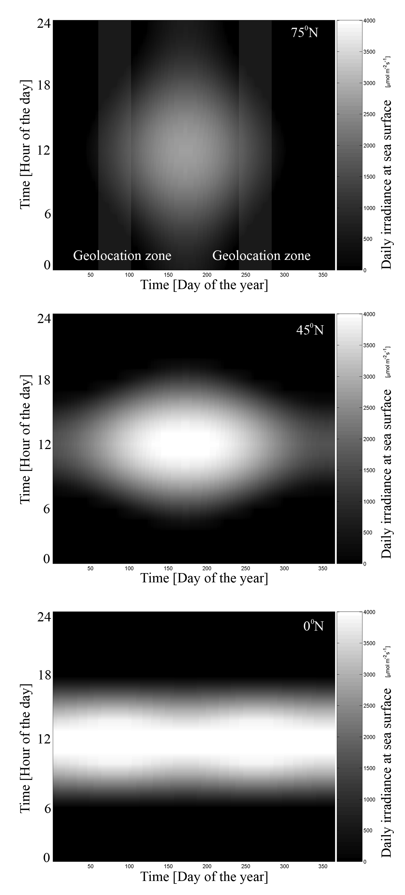

Figure 2 OPP: Add some depth labels to left. Put A in circle on right, remove A, A2, A3.

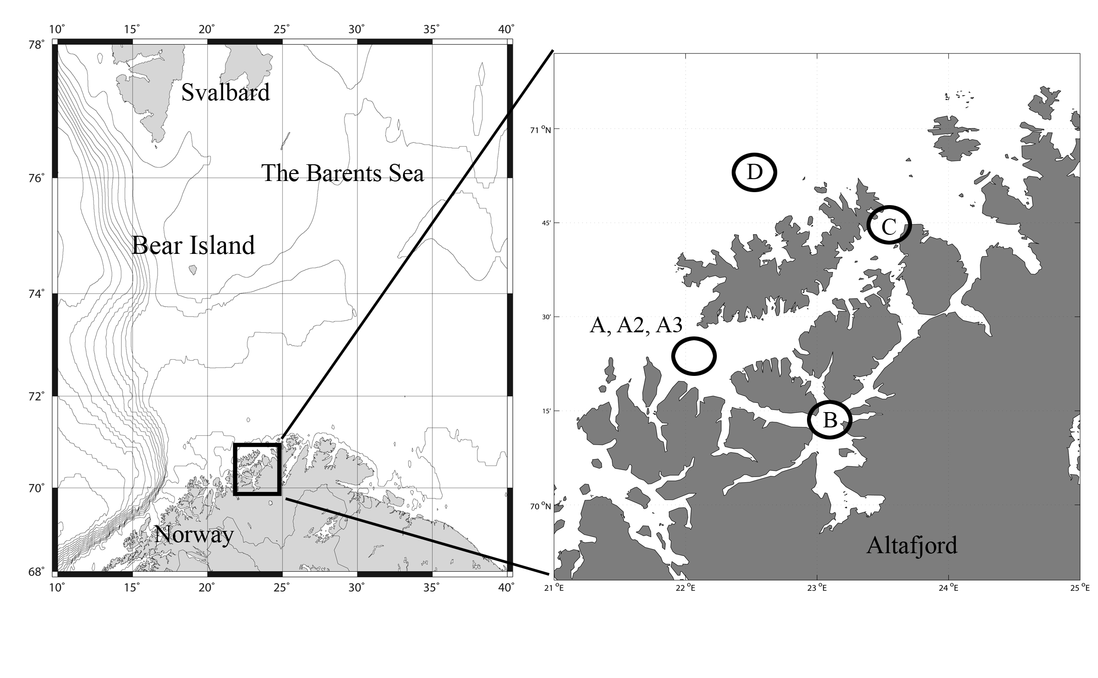

Figure 3a BÅ Can you add x and y labels (latitude N, longitude E)

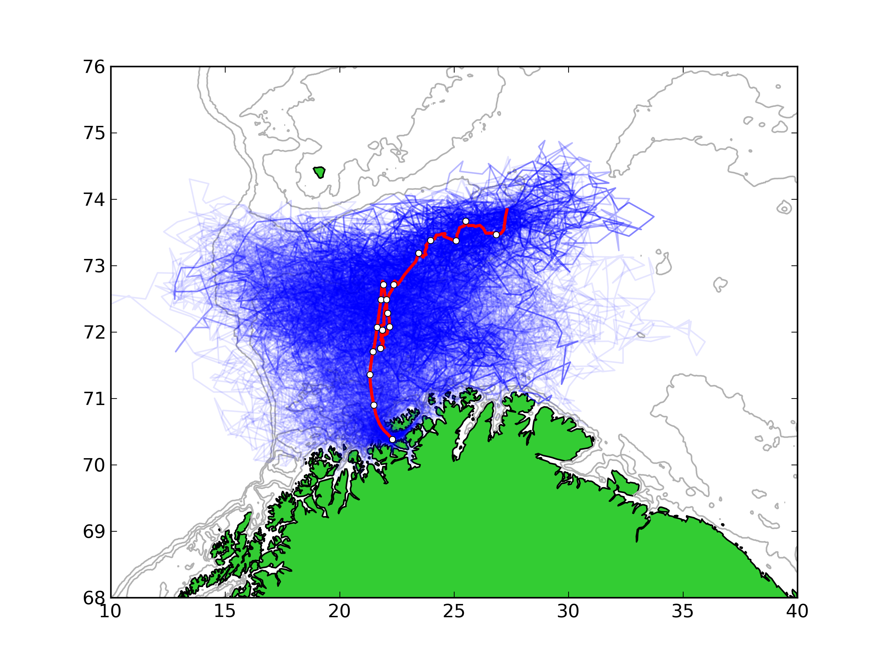

Figure 3b BÅ: Can u match y axes for 3b and 4b?

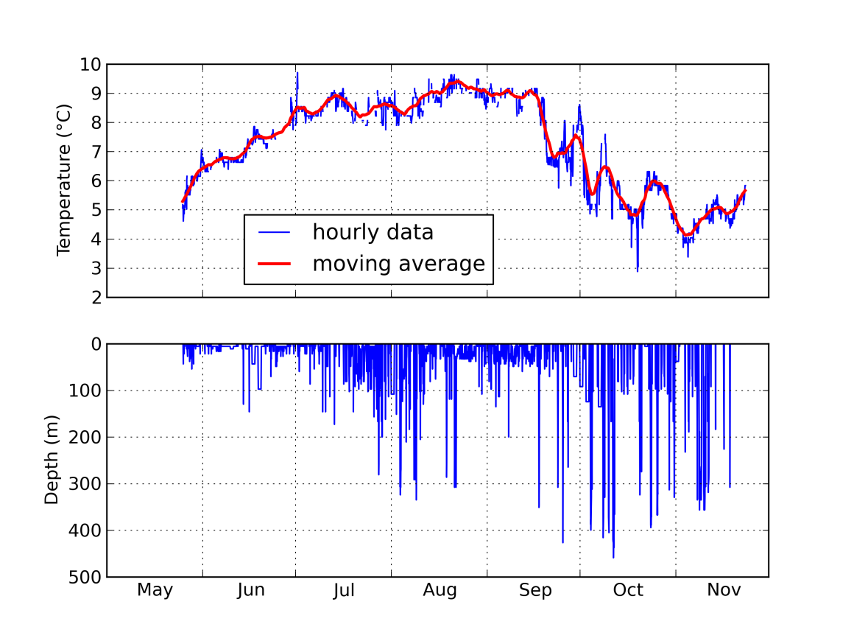Figure 4a

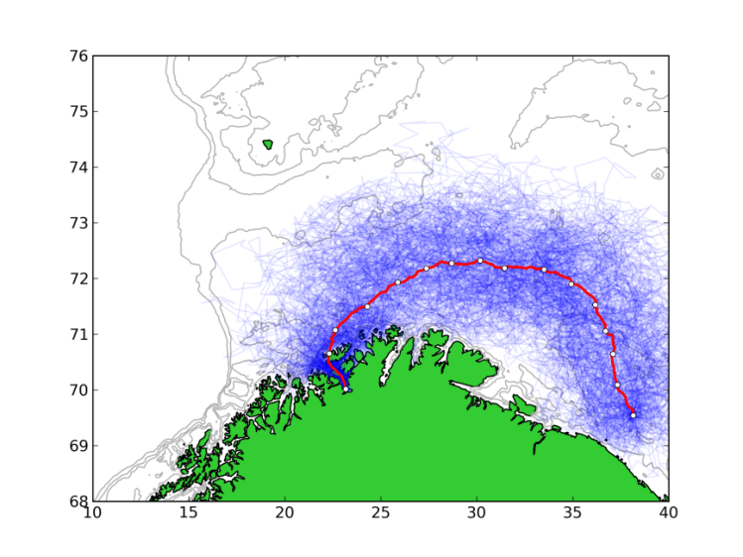

Figure 4b

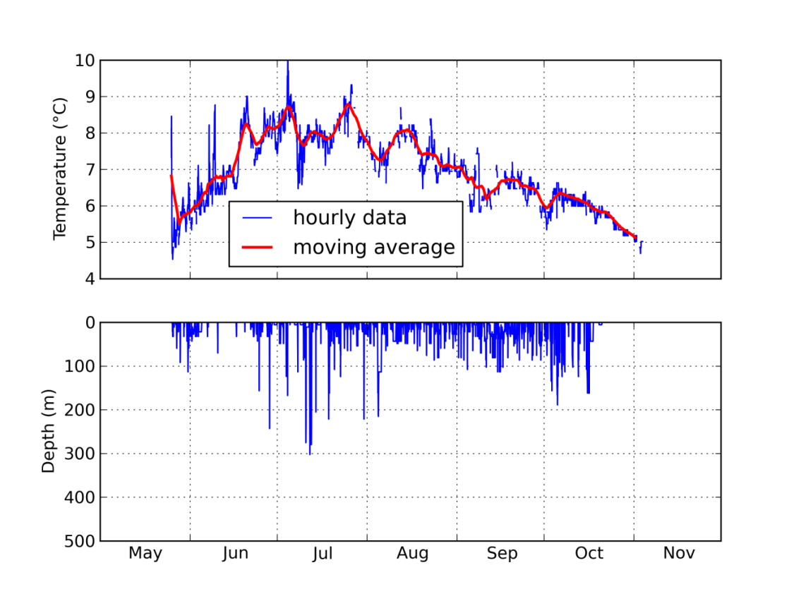Figure 5a DR: Fixing up legend, pop-up location keep green

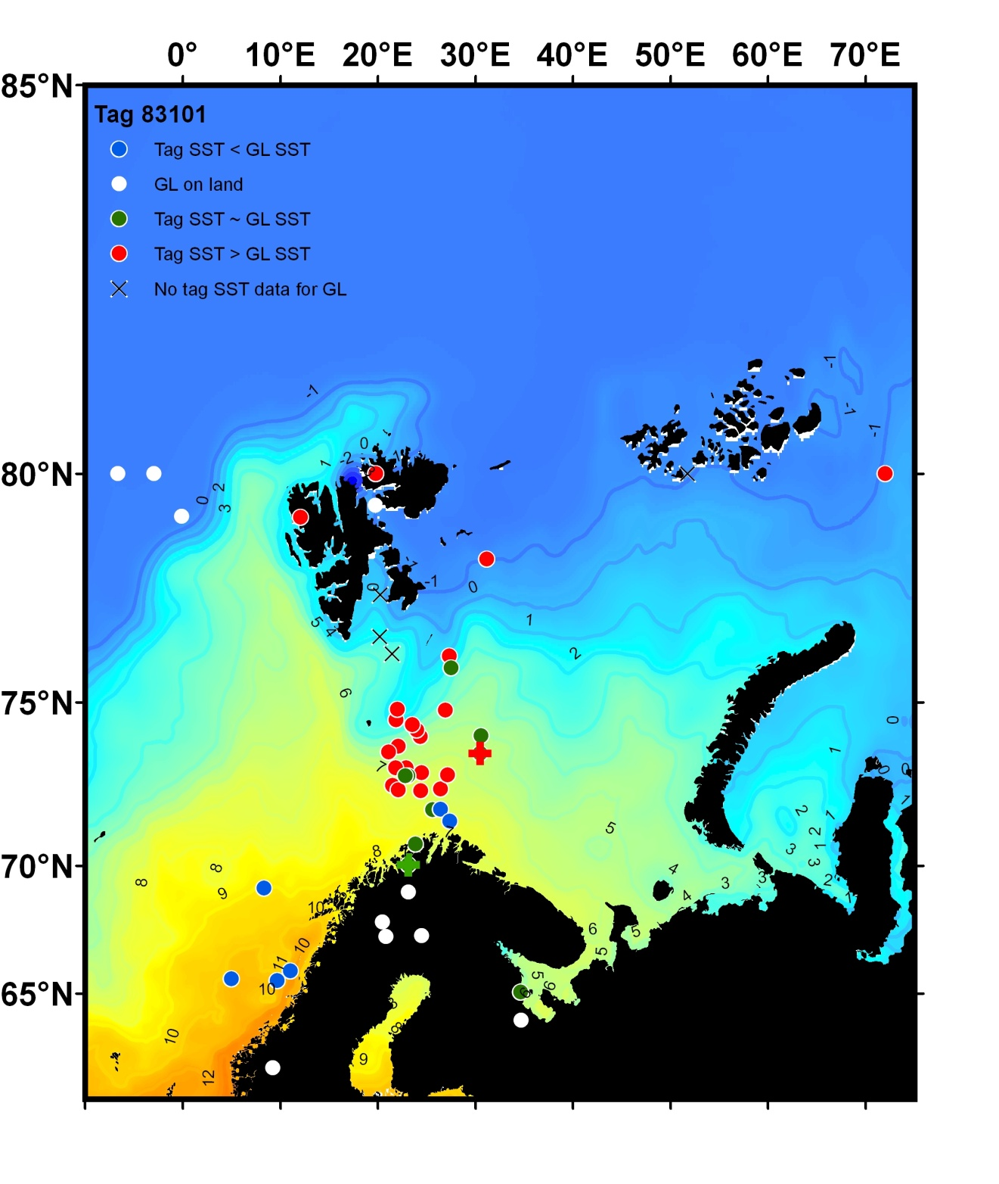

Figure 5b DR: Fixing up legend, pop-up location keep green

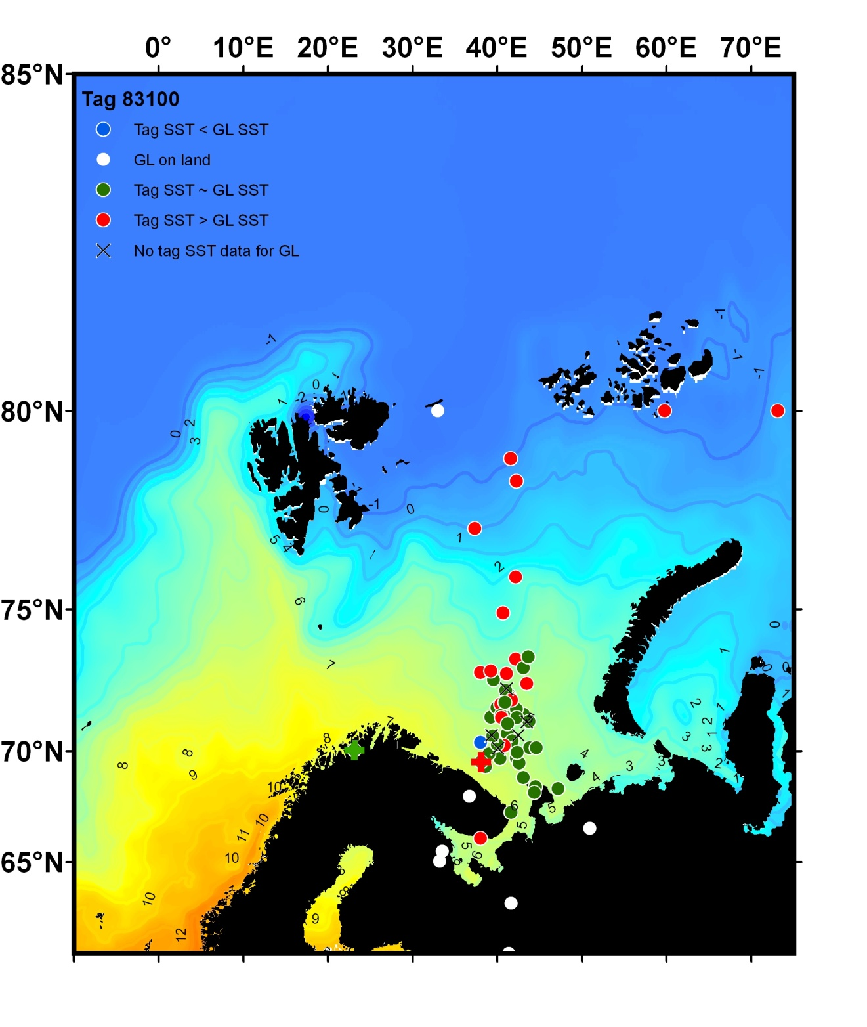Figure 6a BÅ Can you add x and y labels (latitude N, longitude E)

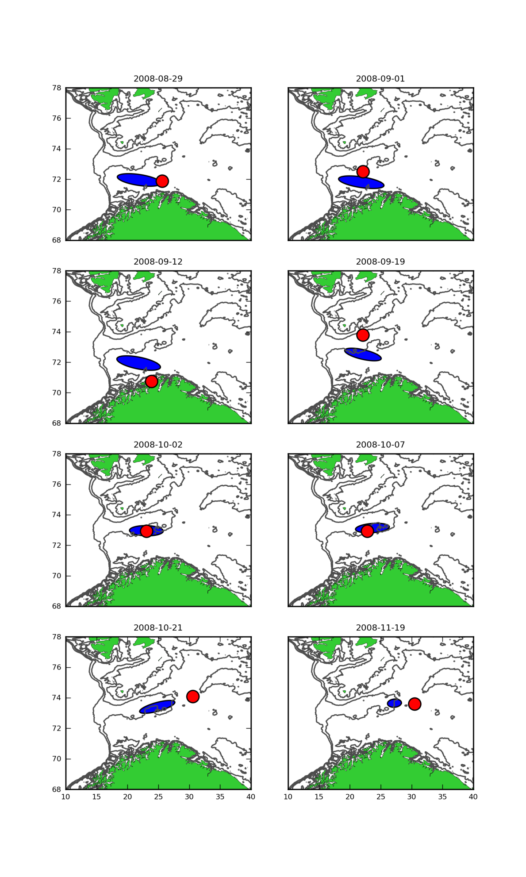

Figure 6b

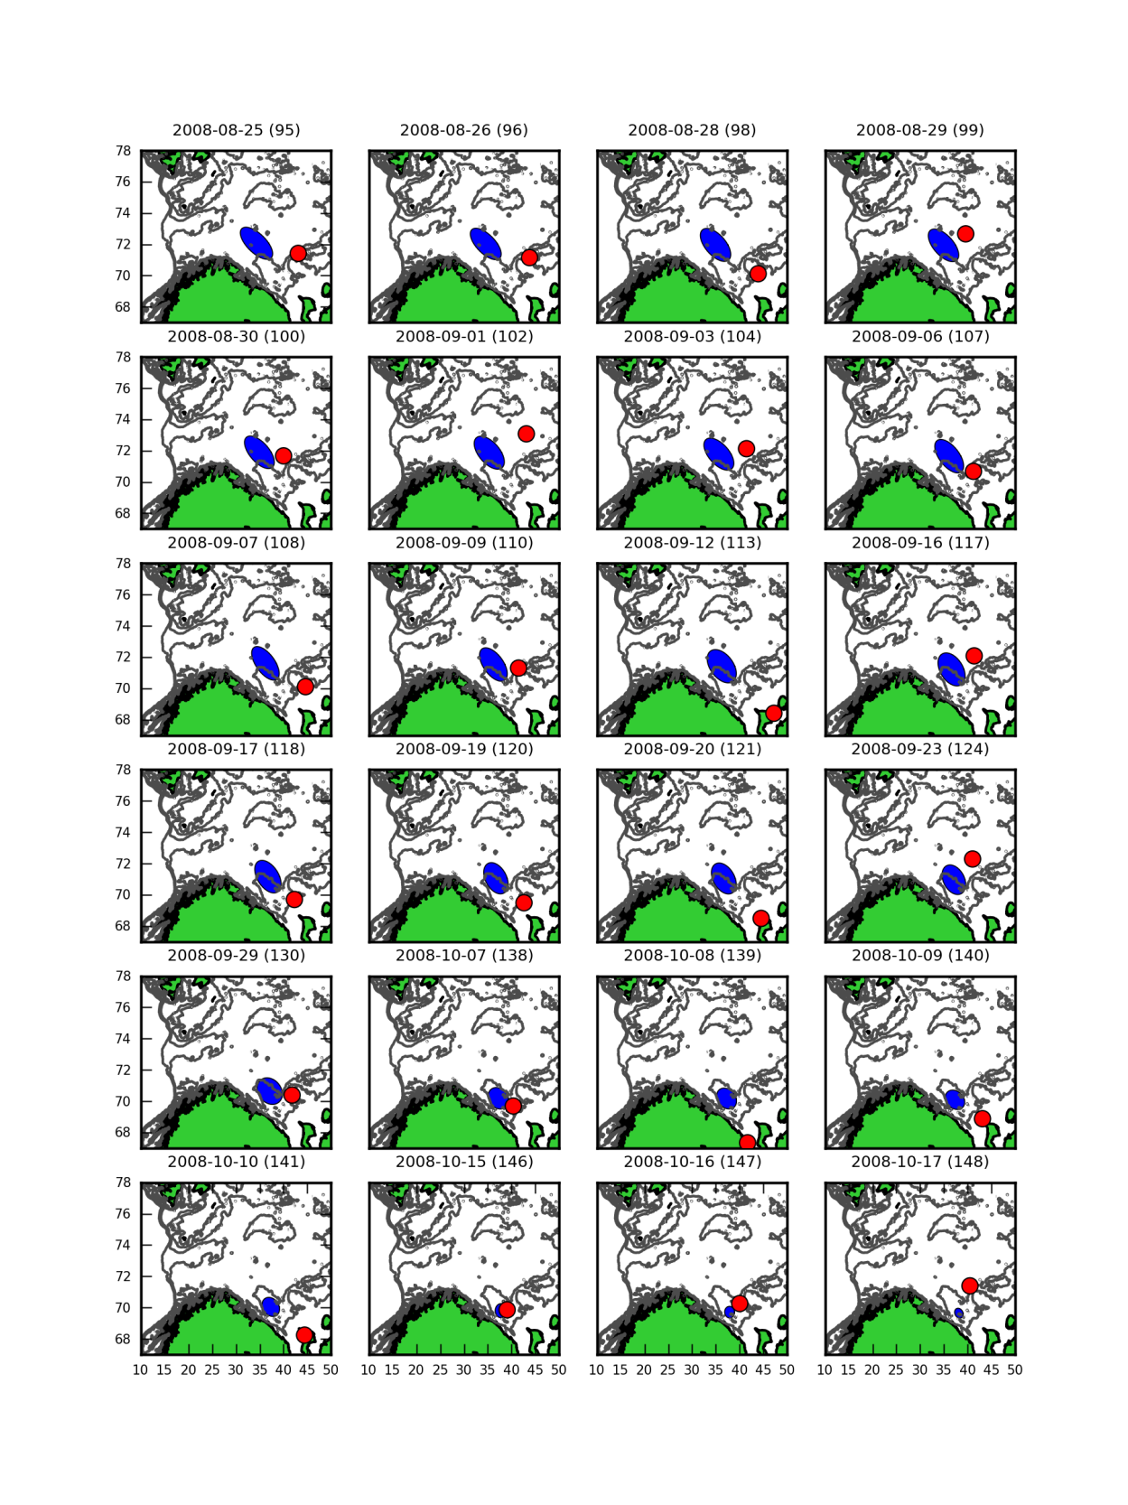Figure 7 BÅ Can you add x and y labels (latitude N, longitude E)

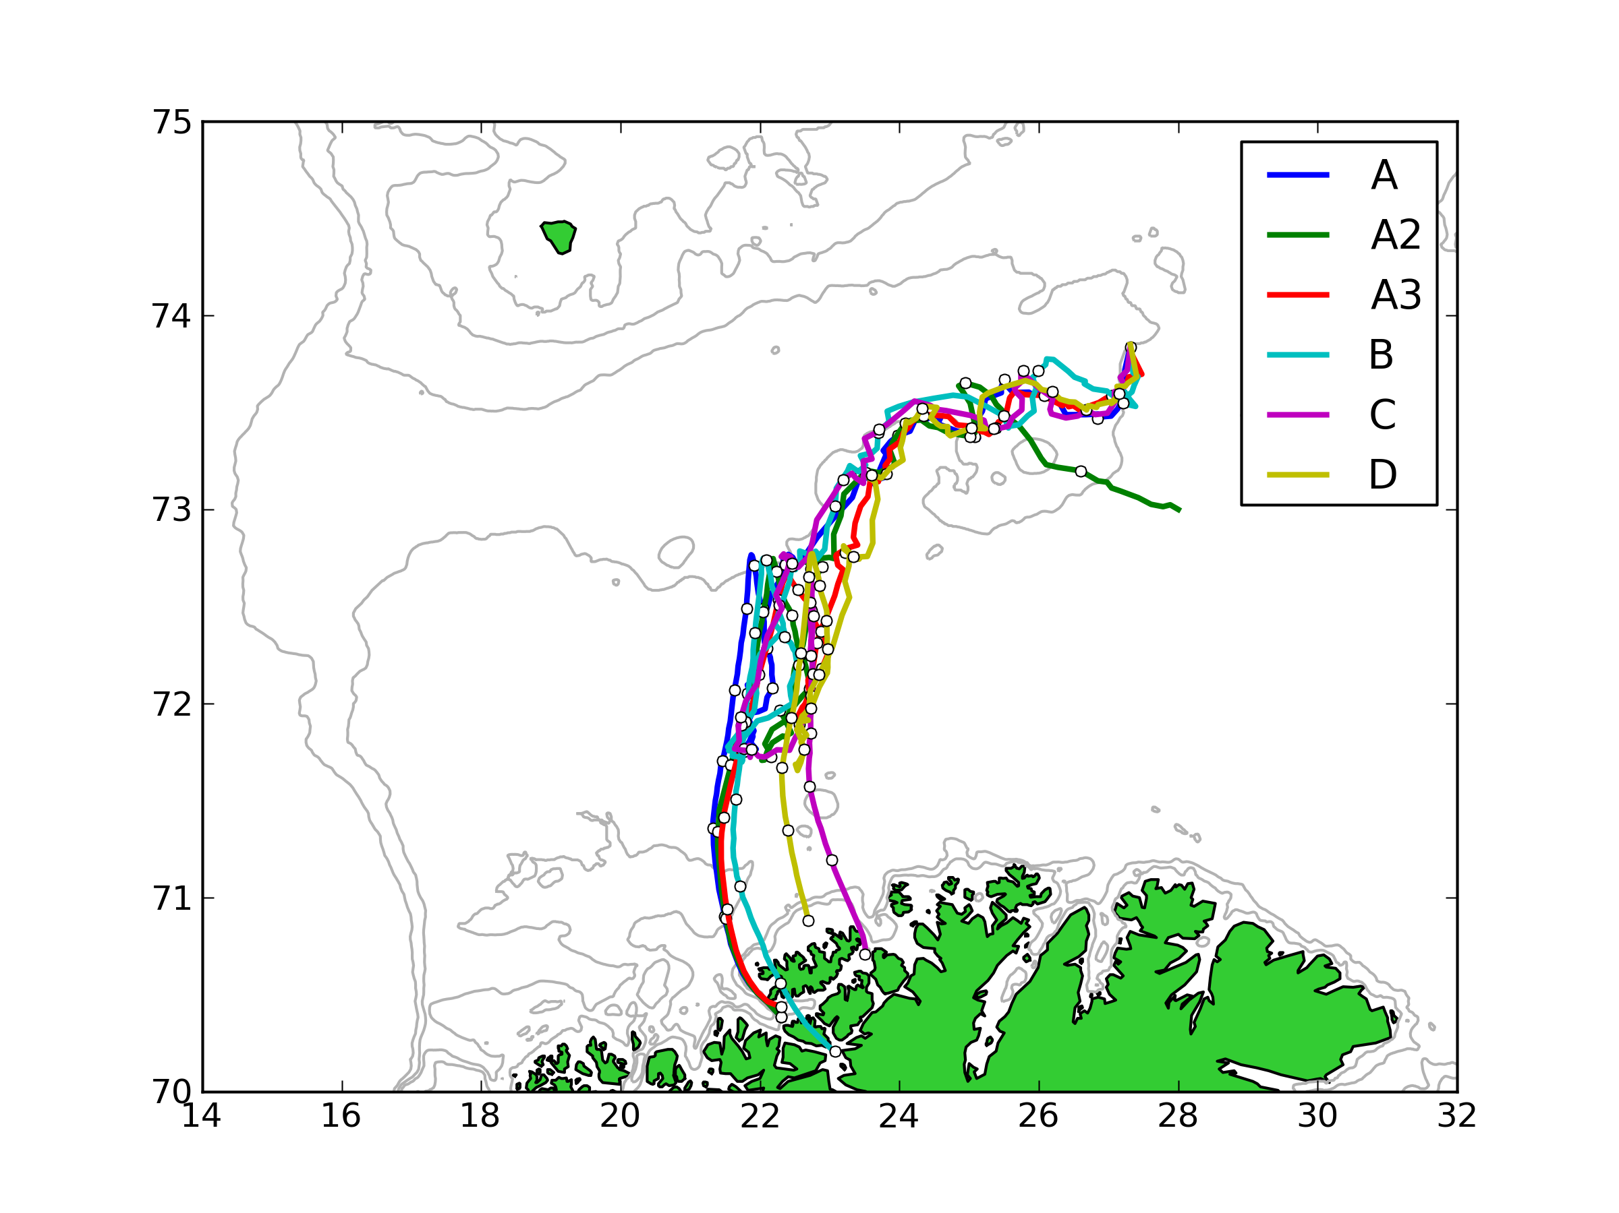

Figure 8 BÅ Can you add x and y labels (latitude N, longitude E) Also, can you make sure the geolocation that is near land (2008-09-12) was removed? I like how you put stars where the geolocations were on the alternate plot… can you put them on this one? I think it would really add a lot to the manuscript if we had a plot for Tag 2 as well. I think the trajectories will look a lot different once they are constrained through the geolocations (which are further east than the pop-up location)

